Project CM

Version 1.0

Revision History

|  |  |  |  |
| --- | --- | --- | --- |
| Date | Version | Description | Author |
| 07/May/2014 | 1.0 | Initial test logs | Storm Cloud Development |
|  |  |  |  |
|  |  |  |  |
|  |  |  |  |

Table of Contents

1. BDD – Test Cases 4

1.1 Brief Description 4

1.2 Use Cases 4

2. Test Coverage 4

3. Test log file 5

# BDD – Test Cases

## Brief Description

As there is no Cucumber like framework compatible with Python 3.4, we use Selenium for functional testing. Selenium is also a behavior driven testing framework and uses the default internet browser to simulate real user interaction.

## Use Cases

We test the use cases “login”, “create new entry in address book” and “logout”. As they are all in the same test class, there is only one log for all of those cases. The test code can be found on github: <https://github.com/tobias-engelmann/ProjectCM/blob/master/src/adressbook/tests_selenium.py>

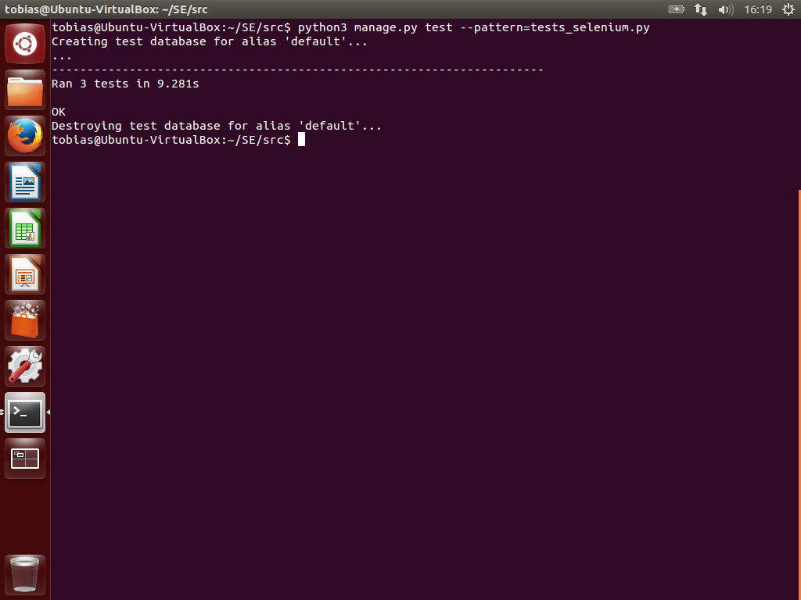

In the picture you can see the call of the selenium test in the first line. Then the test is set up and executed afterwards. The result shows, that all three tests run through green.

# Test Coverage

We use coveralls.io to track our test coverage. Our actual test coverage is at **83.74%** and can be found here: <https://coveralls.io/r/tobias-engelmann/ProjectCM>

# Test log file

We use travis-ci.org for our continuous integration and checking that our unit tests run green. You can find our newest test built at <https://travis-ci.org/tobias-engelmann/ProjectCM>

The unit test which are run can be found here: https://github.com/tobias-engelmann/ProjectCM/blob/master/src/adressbook/tests_unit.py

The recent built (built number 41) run through green as you can see here:

